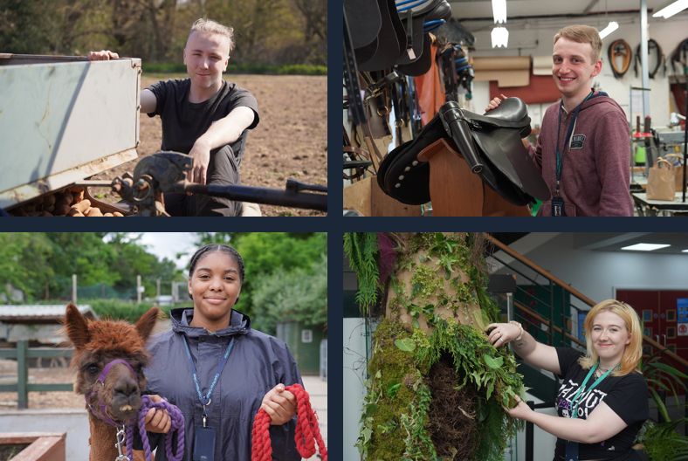

Lecturer in Animal Management

Job Description & Person Specification

capel.ac.uk

capel.ac.uk

capel.ac.uk

capel.ac.uk

capel.ac.uk

capel.ac.uk

capel.ac.uk

capel.ac.uk

**JOB DESCRIPTION & PERSON SPECIFICATION**

**JOB DESCRIPTION**

**Post**  Lecturer in Animal Management

**Scale**  Lecturing

**Grade** Scale 19-35

**Responsible to** Team Leader

**Location** Enfield/Gunnersbury Park/Crystal Palace/Mottingham/Regents Park/Cross College

**Contract** Full-time/Part-time, Fixed-term/Permanent, Term time only

**Key Responsibilities:**

The main responsibilities of the position entails teaching and assessing Animal Management subjects, conducting student tutorials, providing specialised advice on animal care, supporting curriculum development, ensuring animal welfare and coordinating practical activities. The role also involves contributing to the development of new courses, modules, and activities, and fulfilling additional duties as directed by the Director of Animal Management & Saddlery.

**Responsibilities:**

1. Ensure the assessment of various Animal Management subjects meets the standards set by examination bodies.
2. Conduct tutorials, record results, and provide management information to keep track of student progress
3. Offer specialised advice on animal care activities and stay updated on industry developments
4. Assist in curriculum planning, development, and overall support within the Department
5. Conduct research and create engaging course materials for effective teaching.
6. Responsible for the health and welfare of the College’s animal stock
7. Coordinate with animal care workers, technicians, and internal staff to organise practical student activities
8. Liaise with external bodies, visiting speakers, and legal welfare organisations to enhance the educational experience
9. Ensure strict adherence to health and safety regulations at all times.
10. Provide specialised input for the development of new courses, modules, and activities
11. Perform any other duties of a similar nature as required by the Director of Animal Management & Saddlery.

**General Responsibilities:**

1. Promote and implement all College policies, particularly those which refer to health & safety, equality of opportunity and Safeguarding young people and vulnerable adults
2. Participate in College programmes of staff appraisal and continuing professional development
3. Develop effective working relationships internally and with external partners
4. To operate at all times in line with the College’s values and behaviours
5. Undertake other duties as may reasonably be required in the interests of the efficient functioning of the College

**PERSON SPECIFICATION**

**Qualifications**

* Possess a Level 2 qualification in English and Maths or a willingness to achieve within a specified period
* Degree or HND (or equivalent) in a relevant field (Animal Management, Zoology, Biology, Animal Behaviour or similar)
* A teaching qualification is desirable
* Assessor awards are desirable

**Experience**

* A background in the animal industry (zoo/farm) species, together with the commitment to put animals’ needs first
* Experience in handling and managing animals for educational purposes
* Experience of presenting animals for the education of students
* Experience of working in an educational or training environment
* Experience of working with 16-18 year olds, young adults and adult learners
* Administrative experience

**Skills, Abilities and Knowledge**

* Knowledge on zoo management, animal behaviour, enrichment and primate management and animal business
* The ability to develop positive working relationships with individuals at all levels
* Excellent verbal and written communication skills
* Excellent administrative skills
* Excellent organisational skills
* The ability to work on own initiative and as part of a team
* A commitment to and enthusiasm for the teaching and guidance of students at all levels
* Familiarity with Information Learning Technology applications and an active interest in use of instructor led training

**Other Factors**

* An understanding of and commitment to safeguarding young people and vulnerable adults
* Ability to form and maintain appropriate relationships and personal boundaries with children and young people/vulnerable adults
* Emotional resilience
* The ability and determination to promote equality, diversity and inclusion throughout all aspects of College life, including employment and service delivery
* Should the position involve regular driving, a clean driving licence is required