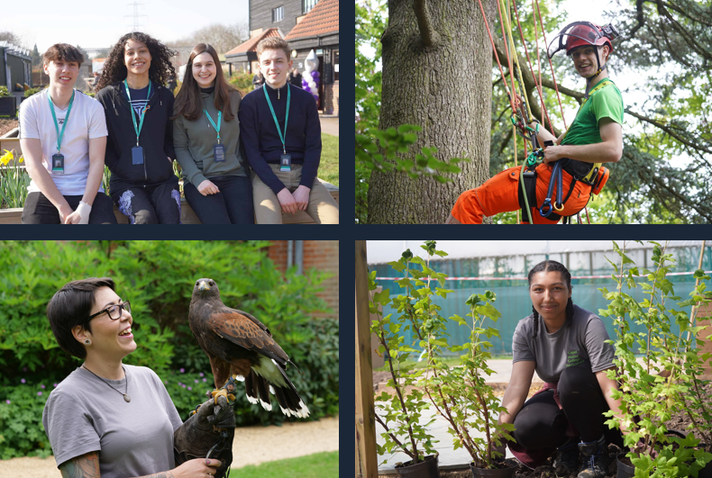

Apprentice Gardener

Job Description & Person Specification

capel.ac.uk

capel.ac.uk

Why Capel Manor College?

capel.ac.uk

A note from the Principal

capel.ac.uk

capel.ac.uk

For further information please contact our HR team.

capel.ac.uk

**JOB DESCRIPTION & PERSON SPECIFICATION**

**JOB DESCRIPTION**

**Post**  Apprentice Gardener

**Scale**  Business and Learning Support

**Grade** National Minimum Wage

**Responsible to** Gardens Manager

**Location** Enfield/Gunnersbury Park/Crystal Palace/Mottingham/Regents Park/Cross College

**Contract** Full-time/Part-time, Fixed-term/Permanent, Term time only

**Key Responsibilities:**

The key responsibility of the Apprentice Gardener is to undertake the necessary day-to-day duties maintaining and developing a comprehensive plant collection including pruning and cultural operations. Maintaining grounds and gardens to a very high standard.

Attending one day at college in term time and four days working in the gardens/grounds.

**Responsibilities:**

1. Carry out weeding, forking, hoeing, mulching and fertilising
2. Carry out day-to-day maintenance of fine turf areas including treatment for pests, diseases and weed control where qualified
3. Carry out pest and disease control on various plants and herbicide treatments* of lawns (* subject to attaining qualification as part of training)
4. Undertake the seasonal planting of trees, shrubs and bedding plants to a scale plan
5. Assist the propagator in the production and cultivation of plants
6. Undertake informative pruning and management of low level trees and shrubs
7. Carry out various land-based horticultural and environmental projects (soft and hard landscaping)
8. Assist in the setting up and display arrangements for shows and major exhibitions e.g. RHS Chelsea
9. Care for and maintain footpaths and walkways
10. Other gardening duties such as mowing lawns, leaf clearance, and hedge cutting
11. The post holder will be required to participate in the weekend duty on a rota basis (times set by the Garden Managers). Hours are additional to the normal working week and are paid at a flat rate in accordance with the terms and conditions of service for Business and Learning Support Staff
12. Apprentices will be required to ensure that standards required by the College are maintained. Attendance, punctuality and keeping up with Learner Journals

**General Responsibilities:**

1. Promote and implement all College policies, particularly those which refer to health & safety, equality of opportunity and Safeguarding young people and vulnerable adults
2. Participate in College programmes of staff appraisal and continuing professional development
3. Develop effective working relationships internally and with external partners
4. To operate at all times in line with the College’s values and behaviours
5. Undertake other duties as may reasonably be required in the interests of the efficient functioning of the College

**PERSON SPECIFICATION**

**Qualifications**

* Possess a Level 2 qualification in English and Maths or a willingness to achieve within a specified period
* Evidence of continuous professional development

**Experience**

* Previous experience working outside
* A strong interest in horticulture
* Previous gardening experience

**Skills, Abilities and Knowledge**

* Ability to work to deadlines
* The ability to develop positive working relationships with individuals at all levels
* Attention to detail
* Flexible and able to work under pressure
* Willing to be trained on a number of horticultural machines
* Sound administrative skills
* To be able to work unsupervised
* Computer literate
* Ability to work on own initiative
* The ability to communicate effectively orally and in writing
* Flexible approach to working hours

**Other Factors**

* An understanding of and commitment to safeguarding young people and vulnerable adults
* Ability to form and maintain appropriate relationships and personal boundaries with children and young people/vulnerable adults
* Emotional resilience
* The ability and determination to promote equality, diversity and inclusion throughout all aspects of College life, including employment and service delivery
* Should the position involve regular driving, a clean driving licence is required