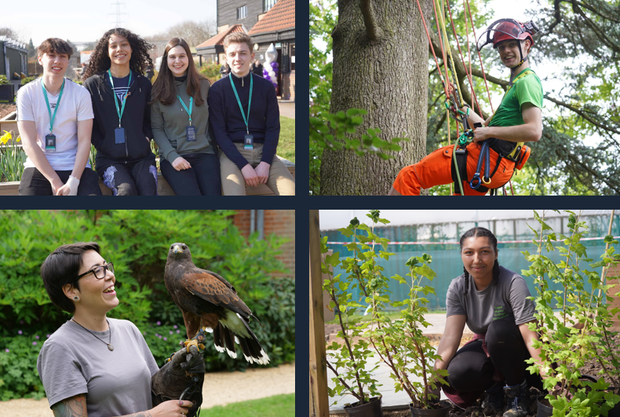

Farm shop Assistant

Job Description & Person Specification

capel.ac.uk

capel.ac.uk

capel.ac.uk

capel.ac.uk

capel.ac.uk

**JOB DESCRIPTION & PERSON SPECIFICATION**

**JOB DESCRIPTION**

Why Capel Manor College?

A note from the Principal

**Post**  Farm Shop Assistant

**Scale**  Business and Learning Support

**Grade** Scale 3

For further information please contact our HR team.

**Responsible to** Forty Hall farm Manager

**Location** Forty Hall Farm

**Contract** Casual

**Key Responsibilities:**

The key responsibility of the Farm Shop Assistant is providing customer service in the Forty Hall Farm Shop, and various administrative and financial responsibilities associated with the Farm Shop.

**Responsibilities:**

1. Greeting and serving customers in the Farm Shop and dealing with customer enquiries, as well as visitor enquiries relating to Farm events, opening hours and operations.
2. Welcoming visitors to the Farm and taking entrance fee, and providing information about the Farm.
3. Set up and opening of Farm Shop in the morning, including display of fresh produce, setting up of a payment terminal and distribution of local signs.
4. Monitoring stock levels throughout the day and stocking up shelves as needed, and monitoring the shelf life of products.
5. Responsible for shop security during opening hours, ensuring shop is fully locked when left and ensuring stockroom remains locked during the day.
6. Daily stock control of fresh produce, ensuring the quality of Farm-grown salad and vegetables on display is maintained at a high standard.
7. End of day banking and cashing up of the payment terminal and transferal of any daily cash takings to the Farm safe.
8. Pricing of new stock, dealing with new deliveries, and creating and maintaining product displays.
9. Cleaning and maintenance of a tidy workspace and shopping areas, and following of shop’s daily Health and Safety procedures (incl.checking freezer temperatures, checking use-by dates, regular cleaning etc.).
10. Assisting with Farm Shop social media activity, by contributing to Farm Instagram.
11. Helping at Farm open days and events, including the Forty Hall Farm Lambing Weekend and monthly Farmers Market.

**General Responsibilities:**

1. Promote and implement all College policies, particularly those which refer to health & safety, equality of opportunity and Safeguarding young people and vulnerable adults
2. Participate in College programmes of staff appraisal and continuing professional development
3. Develop effective working relationships internally and with external partners
4. To operate at all times in line with the College’s values and behaviours
5. Undertake other duties as may reasonably be required in the interests of the efficient functioning of the College

**PERSON SPECIFICATION**

**Qualifications**

capel.ac.uk

* Possess a Level 2 qualification in English and Maths or a willingness to achieve within a specified period
* Evidence of continuous professional development

**Experience**

* Experience of working in a supervisory role.
* Experience of working in a retail environment
* Experience in a customer service environment
* Experience of managing competing priorities and managing own time effectively

**Skills, Abilities and Knowledge**

* The ability to develop positive working relationships with individuals at all levels
* Excellent communication skills, ensuring good communication between shop staff, management and other farm colleagues
* Have customer service experience or be used to responding to and dealing with customers and members of the public
* Have good numeracy and literacy skills and competent using payment terminals and other shop equipment.
* To be calm and able to work under pressure, at times when the shop may get busy, and to use time efficiently.
* The ability to work effectively as part of a team, supporting others as required
* Be competent using Instagram, or willing to learn new skills relating to social media.
* Be supportive of the aims of Capel Manor College and Forty Hall Farm, and committed to sustainable, small-scale food production and retail.

**Other Factors**

* An understanding of and commitment to safeguarding young people and vulnerable adults
* Ability to form and maintain appropriate relationships and personal boundaries with children and young people/vulnerable adults
* Emotional resilience
* The ability and determination to promote equality, diversity and inclusion throughout all aspects of College life, including employment and service delivery
* Should the position involve regular driving, a clean driving licence is required