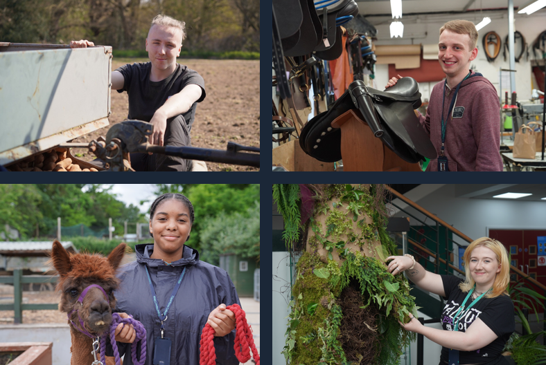

Professional Short Course Lecturer/Assessor
Job Description & Person Specification

capel.ac.uk

capel.ac.uk
capel.ac.uk
capel.ac.uk
capel.ac.uk
capel.ac.uk
capel.ac.uk
capel.ac.uk

JOB DESCRIPTION & PERSON SPECIFICATION

JOB DESCRIPTION

Post Professional Short Course Lecturer/Assessor
Scale Lecture Salary scales
Grade Teaching and Learning Scales, Point 19-35
Responsible to Head of Business development and Employer Skills
Location Enfield
Contract Full-time, Permanent

Key Responsibilities:

The key responsibility of the professional short course Lecturer/Assessor will have a wide range and interesting duties and be encouraged to become fully involved in the teaching, development and maintenance of a range of courses organised by the College. It is intended that the lecturer/assessor will support making important contributions to the development of the College's activities both locally, regionally and nationally.

Responsibilities:

- Contribute to the teaching curriculum of the College
- Maintain, contribute to and deliver a quality teaching and learning service
- Maintain a safe and healthy working environment in accordance with the College's health and safety policies and procedures
- Maintain equipment and tools associated with the Professional short courses
- Operate within the College's Equality Framework to achieve targets

Lecturer/Course Development and Co-ordination

- As part of the team, the lecturer/assessor acts as the main point of reference for students in a group, this includes:
  - Providing educational and welfare guidance
  - Monitor and track student records achievement
  - Preparing administrative for reports and audits
  - Participation in activities to publicise courses for external events, college advice events & open days
  - Design and prepare course materials for a range of courses
  - Preparing industry equipment for assessments
  - Maintain checks of equipment
  - Compile surveys and respond to employer and candidate feedback

Subject Specialist Duties and Responsibilities

- Delivery changes and developments may be required in relation to the demands of the School Curriculum Plan
- Supporting curriculum planning and development within the department
- Ensuring regulations and policies relating to health and safety are adhered to at all times, and with specific reference to the undertaking of practical studies
- Track, monitor and oversee servicing industry equipment.
- Observation and complete practical observations
- Develop and maintain self-performance in guidance with new qualifications to support curriculum and employer demands

General Responsibilities:

- Promote and implement all College policies, particularly those which refer to health & safety, equality of opportunity and safeguarding young people and vulnerable adults
- Participate in College programmes of staff appraisal and continuing professional development
- Develop effective working relationships internally and with external partners
- To operate at all times in line with the College’s values and behaviours
- Undertake other duties as may reasonably be required in the interests of the efficient functioning of the College

PERSON SPECIFICATION

Qualifications

- Possess a Level 2 qualification in English and Maths or a willingness to achieve within a specified period
- Qualified City and Guilds Land Based NPTC assessor
- Hold relevant Competence tickets in Horticulture/Arboriculture
- Teaching qualification or willingness to achieve, support will be given to gain accreditation over a specified period
- Assessor award
- Level 3 Emergency First Aid Certificate
- Internal Quality Assurance or a willingness to achieve within a specified time
- Evidence of continuous professional development
- Specialist knowledge in the following expanding areas:
- Arboriculture
- Forestry
- Horticulture
- Land Based Machinery – Operations and Maintenance

Experience

- Sound experience of teaching and assessing in a college or training environment
- Experience of working with learners with different learning needs
- 10 years or more working in the Horticulture/Arboriculture sector.

Skills, Abilities and Knowledge

- A commitment to and enthusiasm for the teaching and guidance of students at all levels
- The ability to develop positive working relationships with individuals at all levels
- Familiarity with Information Learning Technology applications
- To be able to instruct and assess practical skills
- The ability to work effectively as part of a team, supporting others as required
- Sound administrative skills
- Active interest in use of ILT to improve access to learning
- The ability to communicate effectively orally and in writing
- Effective organisation skills and ability to work on own initiative and as part of a team

Other Factors

- An understanding of and commitment to safeguarding young people and vulnerable adults
- Ability to form and maintain appropriate relationships and personal boundaries with children and young people/vulnerable adults
- Travel to other sites
- Willingness to learn and teach other subjects in Horticulture/Arboriculture.
- Emotional resilience
- Relevant teaching and learning on programmes across all provision of the college
- The ability and determination to promote equality, diversity and inclusion throughout all aspects of College life, including employment and service delivery
- Should the position involve regular driving, a clean driving licence is required

